Call for Papers: Grave Matters; Death and dying in Dublin 1500 - 2000
A one day conference at Glasnevin Cemetery
Organised by the Dublin City Research Group
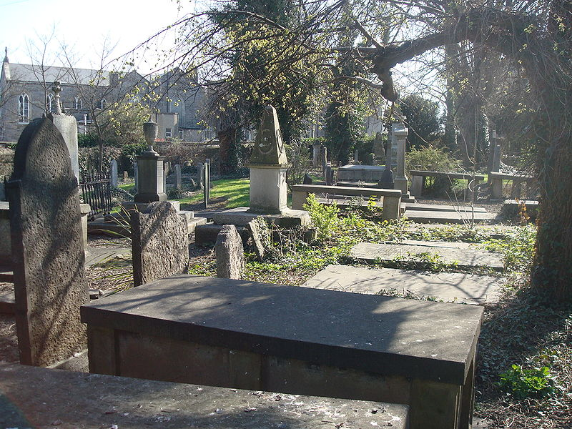

Funeral rites and practices, expressions of grief, and symbols of death including sculptures and literary descriptions tell us a great deal about a society, its values and concerns. For centuries Dubliners have left very visible signs and monuments throughout the landscape that allow us to gain some understanding about their attitudes towards death. But how did these societies really cope with death, loss and grief?
On Saturday 12 of April 2014 a one day conference in Glasnevin cemetery aims at exploring the social, economic, legal and medical aspects of dying in Dublin 1500-2000. The Dublin City Research group invites relevant papers from researchers in all disciplines who are undertaking work on post-medieval Dublin.
To submit a proposed abstract (200-400 words) please email Lisa Griffith (griffitl@tcd.ie) by Friday 28 of November or see the History of the City of Dublin Research Group website for further details: http://www.tcd.ie/CISS/dublinresearchgroup.php

